Code:

boolean result = (x <= 7) ? true : false;

Code:

import java.util.Scanner;

public class CalculatorSwitch {

public static void main(String[] args) {

Scanner scanner = new Scanner(System.in);

System.out.print("Enter first number: ");

double num1 = scanner.nextDouble();

System.out.print("Enter second number: ");

double num2 = scanner.nextDouble();

System.out.print("Enter operator (+, -, \*, /, %): ");

char operator = scanner.next().charAt(0);

double result;

switch (operator) {

case '+':

result = num1 + num2;

break;

case '-':

result = num1 - num2;

break;

case '\*':

result = num1 \* num2;

break;

case '/':

result = num1 / num2;

break;

case '%':

result = num1 % num2;

break;

default:

System.out.println("Invalid operator");

return;

}

System.out.println("The result is: " + result);

}

}

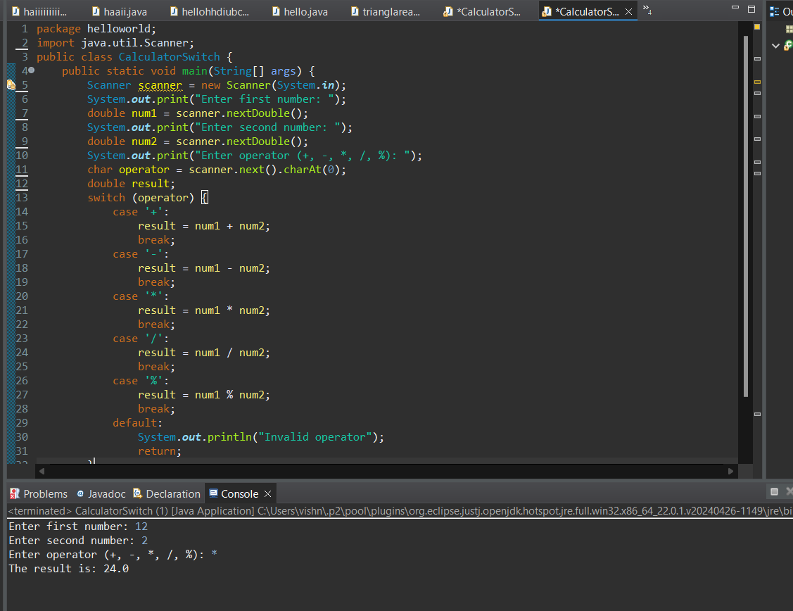

1. True or False: IF/ELSE statements can always be replaced with SWITCH statements.

Code:

import java.util.Scanner;

public class CalculatorIfElse {

public static void main(String[] args) {

Scanner scanner = new Scanner(System.in);

System.out.print("Enter first number: ");

double num1 = scanner.nextDouble();

System.out.print("Enter second number: ");

double num2 = scanner.nextDouble();

System.out.print("Enter operator (+, -, \*, /, %): ");

char operator = scanner.next().charAt(0);

double result;

if (operator == '+') {

result = num1 + num2;

} else if (operator == '-') {

result = num1 - num2;

} else if (operator == '\*') {

result = num1 \* num2;

} else if (operator == '/') {

result = num1 / num2;

} else if (operator == '%') {

result = num1 % num2;

} else {

System.out.println("Invalid operator");

return;

}

System.out.println("The result is: " + result);

}

}

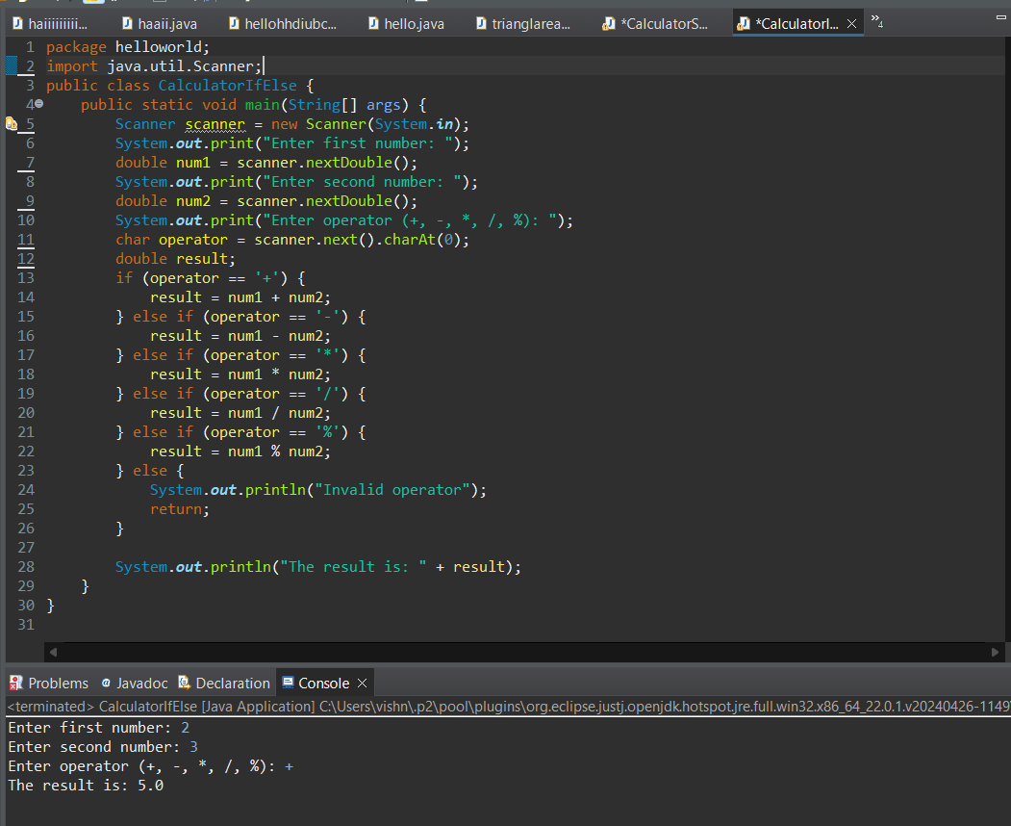

Code:

import java.util.Scanner;

public class WeightOnPlanets {

public static void main(String[] args) {

Scanner scanner = new Scanner(System.in);

System.out.print("Enter your weight on Earth: ");

double earthWeight = scanner.nextDouble();

System.out.println("Choose a planet:");

System.out.println("1. Mercury");

System.out.println("2. Venus");

System.out.println("3. Mars");

System.out.println("4. Jupiter");

System.out.println("5. Saturn");

System.out.println("6. Uranus");

System.out.println("7. Neptune");

int choice = scanner.nextInt();

double conversionFactor = 0.0;

switch (choice) {

case 1: conversionFactor = 0.38; break;

case 2: conversionFactor = 0.91; break;

case 3: conversionFactor = 0.38; break;

case 4: conversionFactor = 2.36; break;

case 5: conversionFactor = 0.92; break;

case 6: conversionFactor = 0.89; break;

case 7: conversionFactor = 1.13; break;

default: System.out.println("Invalid choice"); return;

}

double planetWeight = earthWeight \* conversionFactor;

String planetName = "";

switch (choice) {

case 1: planetName = "Mercury"; break;

case 2: planetName = "Venus"; break;

case 3: planetName = "Mars"; break;

case 4: planetName = "Jupiter"; break;

case 5: planetName = "Saturn"; break;

case 6: planetName = "Uranus"; break;

case 7: planetName = "Neptune"; break;

}

System.out.printf("Your weight on %s is %.2f lbs.%n", planetName, planetWeight);

}

}

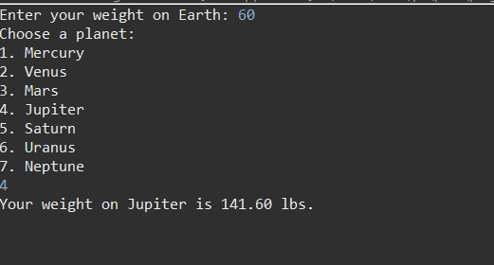

Code:

import java.util.Scanner;

public class MountvilleAdmission {

public static void main(String[] args) {

Scanner scanner = new Scanner(System.in);

System.out.print("Enter your GPA: ");

double gpa = scanner.nextDouble();

System.out.print("Enter your SAT score: ");

int sat = scanner.nextInt();

System.out.print("Are you a valedictorian or salutatorian of a school with 1400 or more students? (yes/no): ");

String vOrS = scanner.next();

boolean admitted = false;

if (vOrS.equalsIgnoreCase("yes")) {

admitted = true;

} else if (gpa >= 4.0 && sat >= 1100) {

admitted = true;

} else if (gpa >= 3.5 && sat >= 1300) {

admitted = true;

} else if (gpa >= 3.0 && sat >= 1500) {

admitted = true;

}

if (admitted) {

System.out.println("Congratulations! You are admitted to Mountville University.");

} else {

System.out.println("Sorry, you are not admitted to Mountville University.");

}

}

}

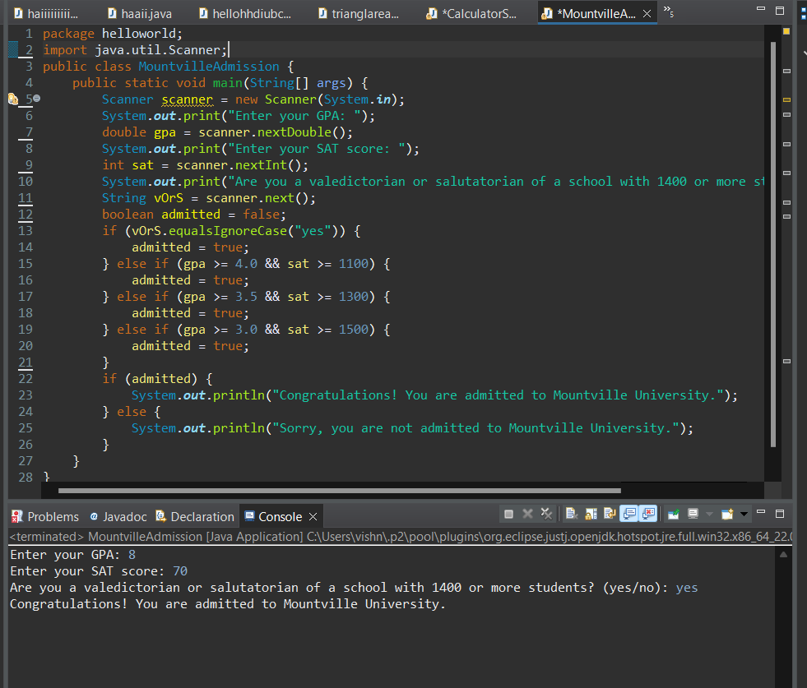

1. .

Code:

import java.util.Scanner;

public class FinalExam {

public static void main(String[] args) {

double average;

int daysAbsent;

boolean exempt = false;

Scanner reader = new Scanner(System.in);

System.out.println("This program will determine if you can get out of the final exam.");

System.out.println("Please answer the following questions.");

System.out.print("What is your average in the class? ");

average = reader.nextDouble();

System.out.print("How many class lectures have you missed? ");

daysAbsent = reader.nextInt();

if ((average >= 90 && daysAbsent <= 3) || (average >= 80 && daysAbsent == 0)) {

exempt = true;

}

if (exempt) {

System.out.println("Congratulations! You are exempt from the final exam.");

} else {

System.out.println("You are not exempt from the final exam.");

}

}

}

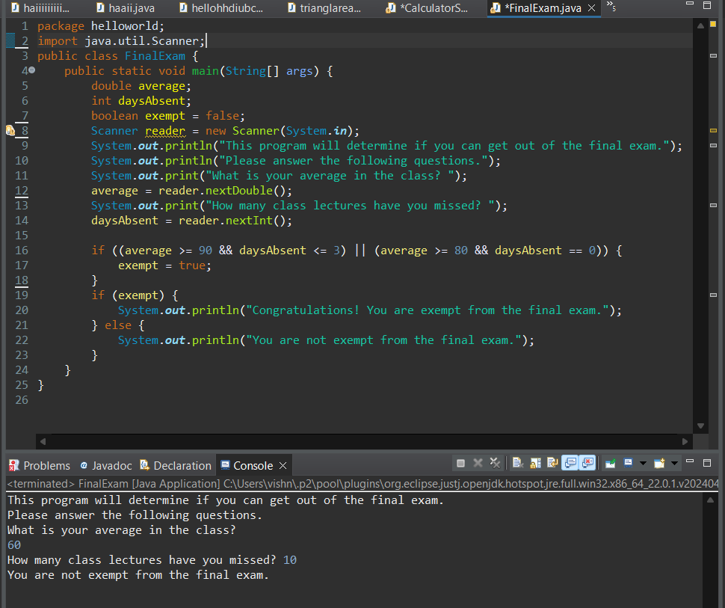

import java.util.Scanner;

public class PaintCalculator {

public static void main(String[] args) {

Scanner scanner = new Scanner(System.in);

System.out.print("Enter the height of the room (in feet): ");

double height = scanner.nextDouble();

System.out.print("Enter the length of the room (in feet): ");

double length = scanner.nextDouble();

System.out.print("Enter the width of the room (in feet): ");

double width = scanner.nextDouble();

double wallArea = 2 \* height \* (length + width);

double ceilingArea = length \* width;

double totalArea = wallArea + ceilingArea;

double litersNeeded = totalArea / 300;

int fiveLiterBuckets = (int) (litersNeeded / 5);

int oneLiterBuckets = (int) Math.ceil(litersNeeded - (fiveLiterBuckets \* 5));

System.out.println("You need " + (fiveLiterBuckets + oneLiterBuckets) + " liters of paint.");

System.out.println("Purchase " + fiveLiterBuckets + " five-liter buckets and " + oneLiterBuckets + " one-liter buckets.");

}

}

